Biology- Class XI

MINERAL NUTRITION- CHAPTER 12

EXEMPLAR QUESTIONS

LONG ANSWER TYPE QUESTIONS

1. It is observed that deficiency of a particular element showed its symptoms initially in older leaves and then in younger leaves.

a. Does it indicate that the element is actively mobilized or relatively immobile?

Answer- This indicates that the elements are actively mobilized. [Refer page 198; Section 12.2.3; NCERT 2021-22]

b. Name two elements which are highly mobile and two which are relatively immobile.

Answer- Refer table given below

|  |  |
| --- | --- |
| Mobile elements: | Immobile elements: |
| Nitrogen | Calcium |
| Potassium | Copper |
| Chlorine | Sulphur |
| Phosphorous | Iron |
| Sodium | Boron |
| Zinc |  |
| Magnesium |  |
| Molybdenum |  |

c. How is the aspect of mobility of elements important to horticulture and agriculture?

Answer- Mobility of an element determines whether its deficiency would affect the younger leaves and parts of the plant or the older leaves and more mature parts. Hence, study of this aspect helps the horticulturist or agriculturist to determine which elements must be vital in their nutrient and soil supplement depending on which part of the plant they are planning to harvest.

2. We find that Rhizobium forms nodules on the roots of leguminous plants. Also Frankia another microbe forms nitrogen fixing nodules on the roots of non-leguminous plant Alnus.

a. Can we artificially induce the property of nitrogen fixation in a plant – leguminous or non-leguminous?

Answer- Yes, such a property of nitrogen fixation can be induced artificially through genetic engineering.

b. What kind of relationship is observed between mycorrihiza and pine trees?

Answer- A specific type of symbiotic relationship- called mutualism is observed between mycorrhiza and pine trees. In such a relationship, both the participants are beneficial for one another. Here, the Fungi collects nutrients from the soil and supplies it to the plants, it also stores excess nutrients for use later. The plant (tree) on the other hand prepares food through autotrophic mode of nutrition and provides it to the fungi too.

c. Is it necessary for a microbe to be in close association with a plant to provide mineral nutrition? Explain with the help of one example.

Answer- Yes, the microbe has to be in a close association with the plant to provide mineral nutrition because the process requires physical contact between the microbes and the plants.

For instance, the legume-bacteria relationship which involves the microbe- Rhizobium and any leguminous plant- alfalfa, sweet clover, sweet pea, lentils, garden pea, etc. The plant synthesizes food for itself and the microbe while the microbe fixes the atmospheric nitrogen into soil nitrogen which can be utilized by plants.

3. What are essential elements for plants? Give the criteria of essentiality? How are minerals classifieds depending upon the amount in which they are needed by the plants?

Answer- Essential elements are the elements that cannot be synthesized by the plant and are required to be taken up from the environment.

Criteria for essentiality-

* The element should be vital for completion of the life cycle of the plant.
* The element should be irreplaceable i.e. its function would not be restored by application of some other element.
* The element should be directly involved in plant metabolism.

Depending on the amount in which they are needed by plants, they are classified into-

* Macronutrients- Present in plant tissues in large quantities. (in excess of 10 mmole Kg –1 of dry matter)
* Micronutrients- Present in plant tissues in small quantities. (less than 10 mmole Kg –1 of dry matter)

[Refer section 12.2.1; NCERT 2021-22]

4. With the help of examples describe the classification of essential elements based on the function they perform.

Answer- Essential elements are grouped into four broad categories on the basis of their diverse functions. These are-

* Essential elements as components of biomolecules and hence structural elements of cells. E.g.- carbon, hydrogen, oxygen and nitrogen.
* Essential elements as components of energy-related chemical compounds in plants.

E.g.- magnesium in chlorophyll and phosphorous in ATP.

* Essential elements that activate or inhibit enzymes.

E.g.- Mg2+ is an activator for both ribulose bisphosphate carboxylase- oxygenase and phosphoenol pyruvate carboxylase; Zn2+ is an activator of alcohol dehydrogenase and Mo of nitrogenase during nitrogen metabolism.

* Essential elements that alter the osmotic potential of a cell.

E.g.- Potassium plays an important role in the opening and closing of stomata.

Refer page 196; section 12.2.1 [NCERT 2021-22]

5. We know that plants require nutrients. If we supply these in excess, will it be beneficial to the plants? If yes, how/ If no, why?

Answer- No, excess nutrients would not be beneficial to the plants. They would cause toxicity in these plants if they are supplied in excess. This could reduce the dry weight of the tissue too. Toxicity caused due to excess of one element can also cause deficiency of some other element due to hindrance in its uptake.

Example- Manganese toxicity causes the appearance of brown spots surrounded by chlorotic veins. It competes with iron and magnesium for uptake and with magnesium for binding with enzymes and inhibits translocation of calcium in the shoot apex.

Refer page 199; Section 12.2.4 [NCERT 2021-22]

6. Trace the events starting from the coming in contact of Rhizobium to a leguminous root till nodule formation. Add a note on importance of leg hemoglobin.

Answer- The events from the moment of contact of Rhizobium with a leguminous root, till the nodule formation is as follows:

* Presence of bacteria and its division around a susceptible root hair in the soil. The bacteria attach themselves to the root hair cells.
* Curling up of the root hair in response to successful infection by the bacteria.
* The infected thread carries the bacteria to the inner cortex where it gets modified into rod-shaped bacteroids and cause inner cortical and pericycle cells to divide. The division and growth of cortical and pericycle cells lead to nodule formation.
* Bacteria are released from the thread into the cells which leads to the differentiation of specialised nitrogen fixing cells.
* Mature nodule formation is completed with the vascular tissues that are continuous with that of the root.

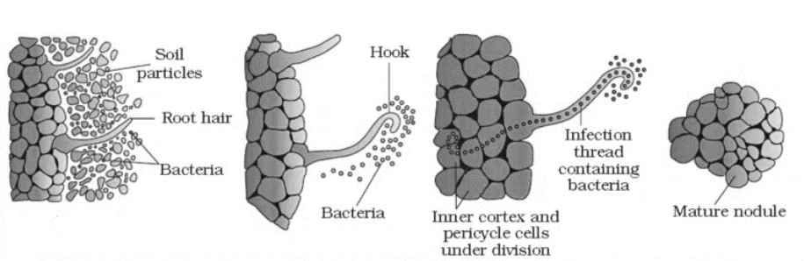

Leg- haemoglobin is a pink coloured pigment which is vital for biological nitrogen fixation. This pigment acts as an oxygen scavenger which creates a favorable anaerobic environment for the proper functioning of Nitrogenase enzyme which actually fixes the atmospheric nitrogen by converting it to ammonia.

Refer page 203; Section 12.6.2 and Figure- 12.4 (legends) [NCERT 2021-22]

7. Give the biochemical events occurring in the root nodule of a pulse plant. What is the end product? What is its fate?

Answer- Atmospheric Nitrogen fixation is the biochemical event occurring in the root nodule of a pulse plant. The process involves the conversion of free Nitrogen in air to ammonia which can be used by the plant. It can be depicted as-

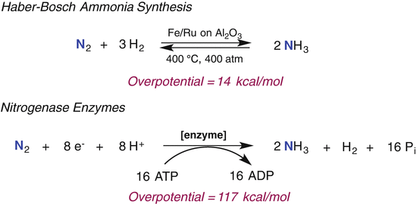

The major end product of this reaction is ammonia (NH3).

Fate of ammonia-

It is used to synthesize amino acids in plants. To be used in synthesis of amino acids, two main processes are followed.

* Reductive amination : In this, ammonia reacts with α-ketoglutaric acid and forms glutamic acid. Enzyme glutamate dehydrogenase is involved in this.

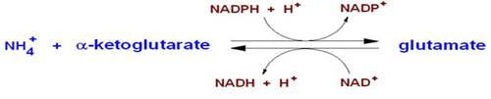

* Transamination : It involves the transfer of amino group from one amino acid to the keto group of a keto acid. The enzyme transaminase catalyses this reaction.

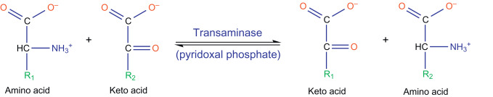

Refer page 203-204; section 12.6.2 [NCERT 2021-22]

8. Hydroponics have been shown to be a successful technique for growing of plants. Yet most of the crops are still grown on land. Why?

Answer- The technique of growing plants in a nutrient solution is known as hydroponics. It has been successfully employed as a technique for the commercial production of vegetables such as tomato, seedless cucumber and lettuce. However, the nutrient solutions must be adequately aerated and constantly given new mineral nutrients to obtain the optimum growth. This is the reason that most of the crops are still grown on land, because the soil already has these nutrients and minerals and it is difficult to constantly monitor and supplement the hydroponic culture.